ACCOMMODATION ANOMALY CLASSIFIER BASED ON RAF RULER ASSESSMENT FOR BINOCULAR VISION DIAGNOSIS

NASIR UDDIN AHMED

SUPERVISOR

DR. ANIS FARIHAN BINTI MAT RAFFEI

CO-SUPERVISOR

DR. NOR SARADATUL AKMAR ZULKIFLI

FACULTY OF COMPUTING UNIVERSITI MALAYSIA PAHANG

**EXECUTIVE SUMMARY**

Binocular vision is the process of coordination and integration of information that the human eyes received into a single binocular percept. Binocular vision depends on several factors. The first one is the anatomy of the visual apparatus, the second one is the motor system, and the third one is the sensory system. The symptoms and clinical features of most binocular vision anomalies fit into known patterns. Accommodation and convergence are highly co-related. Accommodation is the technique by which the eye changes refractive power by altering the lens shape to focus on an object. Convergence is a disconjugate movement in which both eyes rotate inward so that the lines of sight intersect in front of the eyes. In the accommodation reflex, there is also the convergence of the eyes. The RAF (Royal Air Force) Rule provides a binocular gauge to measure objective and subjective convergence as well as accommodation in 1 mm increments. This device is used to detect eye accommodation problems. In this research project, our aim is to develop a classifier model using machine learning techniques and RAF Rules to determine, the anomalies of accommodation which will help doctors and researchers to understand accommodation anomalies.

# CHAPTER 1

**RESEARCH BACKGROUND**

* 1. **Background of the problem**

Accommodation is the feature of increasing the curvature of the lens which affects the frontal surface. During eye accommodation lens diameter decreases. On the other hand lens thickness increases. Accommodation is accompanied by an increase in negative spherical aberration. of the eye. The far point of distinct vision is the position of an object such that its image falls on the retina in the relaxed eye. The far point of the emmetropic eye is at infinity. Near point distinct vision is the nearest point at which an object can be clearly seen while using maximum accommodation. For clinical assessment of accommodation, RAF rules are used. With an RAF ruler NPA (Near Point of Accommodation) is measured. NPA is the closest point at which an object can be seen clearly. There are many types of accommodation anomalies. Accommodation anomalies are visual conditions that can affect the eye's ability to alter its dioptric power to bring an object of regard coincident with the retina. It is mainly classified into two main categories they are Decreased Accommodation and Increased Accommodation. The diagram below represents the classification details.

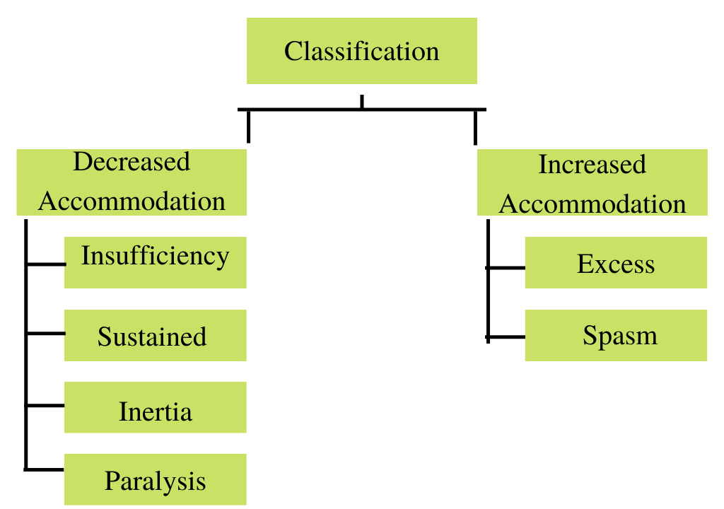

**Figure 1 Accommodation Anomaly Classifications**

Insufficiency of accommodation is the condition in which the accommodative power is constantly less than the lower limit of the normal range. Sustained accommodation is the condition in which the range of accommodation stays normal but cannot sustain for a sufficient amount of time. Inertia is the situation where the patient feels difficulties to alter the range of accommodation. The inability of the ciliary muscles to alter the lens to focus on near or far objects is paralysis of accommodation. Excessive accommodation means the accommodative response is higher than the accommodative stimulus. The spasm occurs when excessive near work is done in bad illumination, bad reading position or mental stress or anxiety. The below chart is known as Duane's 33 standard curves of accommodation in diopters in relation to age. The healthy eye of a young adult has a Power of Accommodation of approximately 4 diopters.

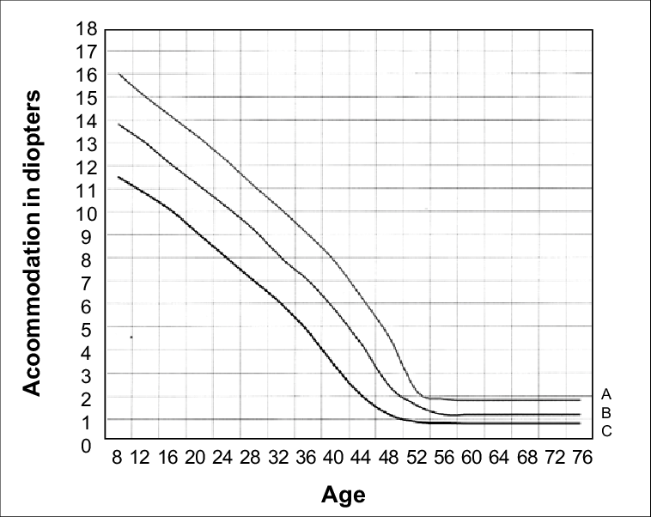

**Figure 2 Duane's 33 standard curve of accommodation in diopters in relation to age**

As a person grows older, the Power of Accommodation typically decreases as a person becomes less able to view nearby objects. It is important to find out eye accommodation criteria, for better treatment. A classifier orders or categorizes data into one or more of a set of “classes.”

* 1. **Hypothesis**

Building an anomaly classifier using RAF rules and machine learning algorithms requires data. The RAF Rule provides a binocular gauge to measure objective and subjective convergence as well as accommodation in 1 mm increments. The amplitude of accommodation is the maximum potential increase in optical power that an eye can achieve in adjusting its focus. It refers to a certain range of object distances for which the retinal image is as sharply focussed as possible. The amplitude of accommodation is measured during a routine eye examination. RAF has 4 different sides and functions. First of all, we need to collect different age groups of patients' data. Next data cleaning and preparation process comes. There we might deal with the missing values if occurs. In the third step, Exploratory Data Analysis and Feature Engineering are Required. In the accommodation anomalies chart, there are different types of anomalies. Based on data we need to decide the factors of anomalies. Categorical and Numerical data can come at any time based on the dataset. In the last step, we need to design the algorithm to develop the classifier model. And then evaluation of the classifier will take place.

* 1. **Research Questions**
* How the data of this research will be collected?
* How the features from the dataset will be selected?
* How the model will be deployed?
  1. **Research Objectives**

* To identify the limitation of current accommodation anomaly detection
* To develop a classifier method for accommodation anomaly detection
* To evaluate the performance of the classifier method

# CHAPTER 2

**LITERATURE REVIEW**

* 1. **Existing Related Works**

Virtual reality games on accommodation and convergence will be discussed. (Zulekha Mohamed Elias, 2019) worked on VR related project to find out the effects of accommodation and convergence. Thirty four subjects participated in this study, out of which 21 were male and 13 were female, with age ranging 18–28 years and mean age of 23. All the subjects had distance visual acuity of 6/6 or better, of which 21 were spectacle wearers. They found that exposure to virtual reality gaming did affect accommodation and convergence systems. After immersion in virtual reality, subjects exhibited a lead in accommodation, where they tend to focus more than required, whereas convergence is receded as there is a shift towards exophoria, due to the loss gains in AC/A ratio.

(Nicola S. Logan; Hema Radhakrishnan; Fiona E. Cruickshank, 2021) worked on IMI Accommodation and Binocular Vision in Myopia Development and Progression. Binocularity is important in the formation of the retinal image. Binocularity improves the accommodative response to defocus and, in turn, blur due to defocus is a useful cue in binocularity. This effect may be different in myopes. Although emmetropization signals are found locally at the retinal level, binocular vision may play a significant role in retinal image focus and therefore in emmetropization and potentially for myopia development.

(Hassan Hashemi, MD, 2019) published Near Points of Convergence and Accommodation in a Population of University Students in Iran. In this project they tried to determine the distribution of the near point of convergence (NPC) and near point of accommodation (NPA) in a young student population in Iran. A cluster sampling method used. All students underwent optometry tests, including visual acuity measurement, refraction, and cover test, as well as ophthalmic examinations. The NPC and NPA were measured using an accommodative target (near Snellen chart).

(Mads G. Eide; Ilona Heldal; Carsten G. Helgesen; Gunvor Birkeland Wilhelmsen, 2019) published Eye-tracking Complementing Manual Vision Screening for Detecting Oculomotor Dysfunction. They tried to figure out vision and oclumotor problems. They followed qualitative study method.

(Beatriz Remeseiro, Noelia Barreira, Luisa S´ anchez-Brea, Lucıa Ramos and Antonio Mosquer, 2018) worked on Machine Learning Applied to Optometry Data. They used VOPTICAL I1 image dataset.

# CHAPTER 3

**RESEARCH METHODOLOGY**

**3.1 Research Framework**

The figure below represents the research framework

**Milestone 1: Analyze the research problem and completion of the concept**

Developing the algorithm for the classifier to detect accommodation anomalies

**Output 3:**

The Classifier

Report Writing

**Milestone 4: Testing and evaluation**

Testing the classifier, performing close test, open test to check the robustness

**Milestone 2: Completion of data collection, data preparation, analysis**

**Output 2:**

The main function and algorithm

Benchmark analysis of existing algorithms with the processed data

Studying different classifier algorithms

**Milestone 3: Development and implement of algorithms for the classifier**

**Output 1:**

Analysed data ready for algorithm design and research

Identify the source of data for the research problem

Developing the solution concept and merging RAF rules with solution

Features engineering

Finding out the important features from the data

Collecting data, preparing the data, analysis

Analyze the research problems for accommodation anomalies

**3.2 Gantt Chart**

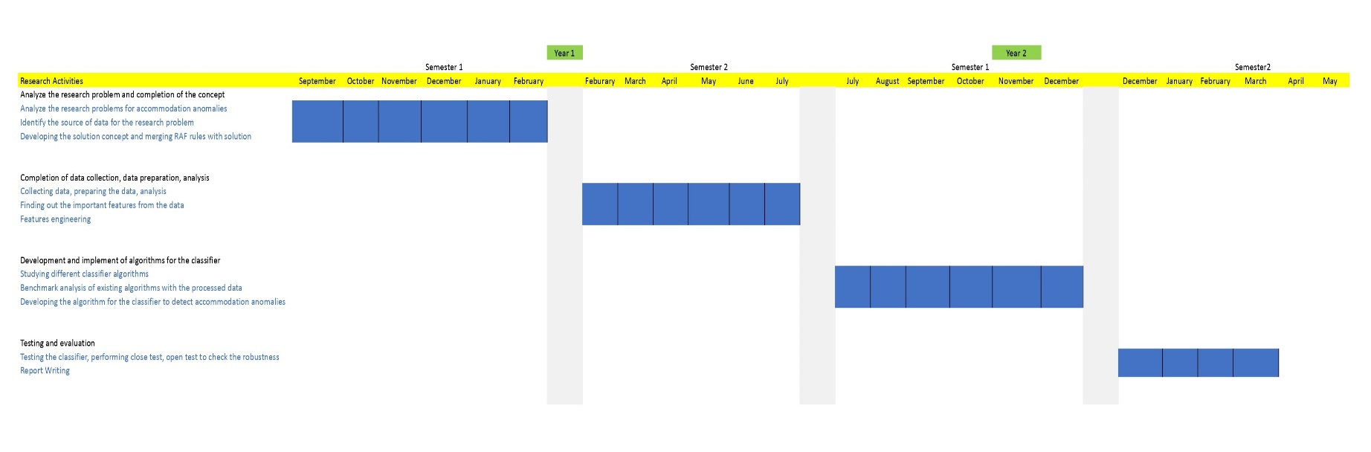

1. **References**

Zulekha Mohamed Elias, Uma Mageswari Batumalai, Azam Nur Hazman Azmi, Virtual reality games on accommodation and convergence, Applied Ergonomics, Volume 81, 2019

Logan, Nicola S. and Radhakrishnan, Hema and Cruickshank, Fiona E. and Allen, Peter M. and Bandela, Praveen K. and Davies, Leon N. and Hasebe, Satoshi and Khanal, Safal and Schmid, Katrina L. and Vera-Diaz, Fuensanta A. and Wolffsohn, James S, IMI Accommodation and Binocular Vision in Myopia Development and Progression, Investigative Ophthalmology & Visual Science, 2021

Hashemi, H., Pakbin, M., Ali, B., Yekta, A., Ostadimoghaddam, H., Asharlous, A., Aghamirsalim, M., & Khabazkhoob, M. (2019). Near Points of Convergence and Accommodation in a Population of University Students in Iran. *Journal of ophthalmic & vision research*, *14*(3)

M. G. Eide et al., "Eye-tracking Complementing Manual Vision Screening for Detecting Oculomotor Dysfunction," 2019 E-Health and Bioengineering Conference (EHB), 2019